**Linux operating system**

An operating system can be described as an interface among the computer hardware and the user of any computer. It is a group of software that handles the resources of the computer hardware and facilitates basic services for computer programs.

An operating system is an essential component of system software within a computer system. The primary aim of an operating system is to provide a platform where a user can run any program conveniently or efficiently.

On the other hand, [Linux](https://www.javatpoint.com/linux-tutorial) OS is one of the famous versions of the UNIX OS. It is developed to provide a low-cost or free OS for several personal computer system users. Remarkably, it is a complete OS Including an X Window System, Emacs editor, [IP/TCP](https://www.javatpoint.com/computer-network-tcp-ip-model), GUI (graphical user interface), etc.

**Architecture of Linux**

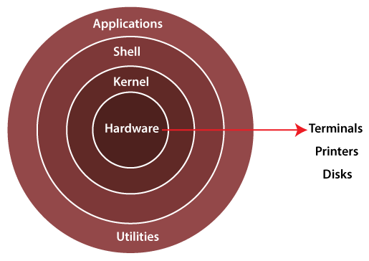

* **Kernel:** At the core of Linux is the kernel. The Linux kernel is responsible for managing system resources, including the CPU, memory, hardware devices, and input/output operations. It provides the fundamental services that the rest of the operating system and user-space programs rely on.
* **User Space**: Above the kernel is the user space, where user-level programs and services run. These programs interact with the kernel through system calls to access resources and perform various tasks.
* **File System**: Linux uses a hierarchical file system, similar to other Unix-like operating systems. The file system provides a way to organize and store data on storage devices such as hard drives and SSDs. Common file systems used in Linux include ext4, XFS, and Btrfs.
* **Processes**: In Linux, processes are instances of running programs. Each process has its own memory space, environment variables, and system resources. The Linux kernel manages processes and provides mechanisms for process creation, scheduling, and communication.
* **Shell:** The shell is a command-line interface that allows users to interact with the operating system by typing commands. There are various shells available in Linux, including Bash (Bourne Again Shell), Zsh, and Fish. Shells provide a way to execute commands, manipulate files, and manage processes.
* **Device Drivers**: Device drivers are software components that enable communication between the kernel and hardware devices such as network adapters, graphics cards, and storage controllers. Linux has a rich ecosystem of device drivers to support a wide range of hardware.
* **Networking Stack**: Linux includes a comprehensive networking stack that provides support for networking protocols, socket communication, and network configuration. It allows Linux systems to connect to networks, the internet, and other devices.
* **Security Model:** Linux has a robust security model with features like user and group permissions, access control lists (ACLs), and mandatory access controls (SELinux, AppArmor). These mechanisms help protect the system and its resources from unauthorized access and malicious software.
* **Package Management**: Linux distributions often include package management systems (e.g., APT, Yum, Pacman) to simplify the installation, update, and removal of software packages. Package managers resolve dependencies and ensure software is installed correctly.
* **Graphical User Interface (Optional):** While Linux is often used in server environments without a graphical user interface (GUI), desktop Linux distributions provide GUI environments such as GNOME, KDE, and Xfce for user-friendly interactions.
* **Library Support:** Linux relies on a rich set of libraries and APIs that help developers create applications. Common libraries include the GNU C Library (glibc) and various other libraries for graphics, sound, and more.
* **Virtualization and Containers**: Linux supports virtualization technologies like KVM and containers through Docker and Kubernetes. These technologies enable efficient resource allocation and isolation for applications and services.
* **File Permissions**: Linux uses a permission system with read, write, and execute permissions for files and directories. These permissions are managed at both the user and group levels.

The architecture of Linux is modular, allowing it to run on a wide range of hardware platforms and be customized for various use cases. Different Linux distributions (e.g., Ubuntu, CentOS, Debian) may have slightly different configurations and package management systems, but they all share the core architecture outlined above.